
JOB DESCRIPTION
Lands and Survey Department
Cayman Islands Government

Job Title: GIS Programmer

Grade: J

Job holder: Vacant

Reports to: Snr. GIS Programmer

Department/Ministry: Lands & Survey Department
Ministry of District Administration & Lands

1. JOB PURPOSE

To work in a team environment developing and supporting software solutions that allow efficient and detailed query, analysis, updating and presentation of information stored within a Geographical Information System (GIS) and associated Relational Database Management Systems (RDBMS).

2. DIMENSIONS

This post, although having no direct management responsibility, provides support to hundreds of government and private users. The GIS Section Comprises 13 GIS Professionals with three teams; development, operations & production, the post holder is a part of the development team lead by the Senior. GIS Programmer. As the central repository for geospatial data, the National GIS is fundamental in supporting multiple initiatives of national importance, and the need for accurate and current information is critical to their success and therefore places a significant responsibility on the post-holder.

These include
- The maintenance and updating of land-related data including a comprehensive cadastral database of over 30,000 land parcels available to the public.
- The maintenance of 8-16 websites on the caymanlandinfo domain.
- 140 -160 Geographic solutions developed/redeveloped/acquired and geographic datasets maintained per annum.
- Deliver 5-20 client-user training and consultation sessions per annum.
- Maintain GIS Services to approximately 800-900 public and private sector users / subscribers.
- Facilitate the supply 1100-1300 Standard and customized maps to numerous public and private customers through traditional and electronic forms inclusive of web services.

- PRINCIPAL ACCOUNTABILITIES
Percentage
Time Spent
- To provide software development expertise in areas concerning software architecture, programming, testing, data management, user interface design and software security in the execution of project development as per the agile team development process.  - To have a comprehensive understanding of departmental procedures, data structures, data management and business processes to support them and to refine or remediate where necessary, such as to develop and document database and application designs where extension or modification of the core system is required for business continuity and improvement.  - To support the departmental website in the programming of mapping, online business services, data access solutions, third-party solution integration, and the delivery of customer support.  - To provide analysis and scripting expertise in developing bespoke geospatial processes and automated jobs for increased service efficiency and productivity.  - Work with users to develop their needs and operational requirements in finalising an appropriate solution to their application.  - To provide emergency support to solving minor hardware, software and network problems that may arise and which can be dealt with expeditiously without necessitating technical support from Computer Services.  - Play an active role in the development of other departmental staff. | 40%  20%  15%  10%  5%  5%  5%
____________________________________________________________________

- ORGANISATION CHART

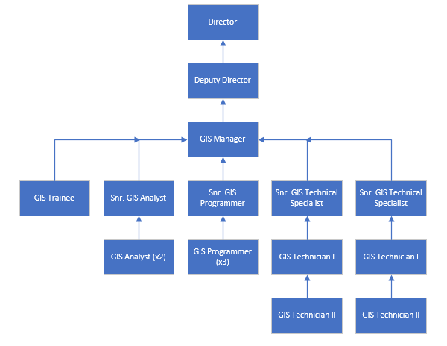

5. BACKGROUND INFORMATION

The National GIS is one of five sections within the Lands & Survey Department. It provides the technology and expertise to enable integrated e-delivery of all digital information for the department and enables the delivery of spatial information for Government as a whole.

GIS technology, particularly the leading edge ESRI software suite used by the department, is subject to continual re-engineering, not only to the data-model but also the development environment. The post-holder is required to keep abreast of all such changes on behalf of all government users in the identification and purchase of appropriate GIS software and hardware products.

The products the National GIS section created have enabled Government to increase its revenue base. This include the sale of Standard and Customized maps and map services, and subscription services.

The post holder will ensure that access to the department online services is available 24/7 and that data is updated continuously based on agreed timelines using scheduled procedures.
_____________________________________________________________________

6. KNOWLEDGE, EXPERIENCE AND SKILLS

The post-holder must possess at minimum a Bachelors degree in Geographical Information Systems, Computer Science, or related programming discipline, plus 4 years industry experience OR a Masters degree in Geographical Information Systems, Computer Science, or related programming discipline, plus 2 years industry experience, ideally within in an environment that has given significant exposure to spatial concepts. The ability to apply programming concepts to Geospatial information is a fundamental requirement of this post.

The post-holder should be able to work as an integral part of a project team dedicated to providing integrated solutions to a wide range of users utilising the ESRI suite of products, and encompassing a variety of supporting technologies and solutions providers.

The post-holder must possess formal training in application development and/or database administration for SQL Server and/or Oracle.

Additionally the post holder should be comfortable in the use and troubleshooting of a wide range of computer peripherals, and the issues associated with their best use practice.

As the GIS team is small, experience with system administration in a Microsoft Windows networked client-server environment would be highly beneficial.

The post holder should have proven knowledge and experience in a number of the following areas of specialisation:

- Software Engineering Principles and Practices
- DevOps tools
- Agile Development methodology with emphasis on Scrum
- Source Control Systems such as GIT
- .Net Programming(C#,VB,C++)
- Python with strong emphasis on spatial development
- ArcGIS API for Javascript
- Web Development (ASP.NET, JavaScript, HTML5, Bootstrap)
- Web Service Development using REST/SOAP/WCF/.NET Web API
- Mobile Application Development (Xamarin)
- Database Development
- Geodatabase Design and Management
- Structured Query Language (SQL), PL/SQL, T-SQL
- ArcGIS Desktop (ArcGIS 10.x & ArcGIS Pro 2.x)
- ArcGIS Server10.x Administration (GIS, Image & GeoEvent)
- ArcGIS Portal/Online Administration
- Application Security
- IOT/GPS Tracking

Proficiency in the following would be a distinct advantage:
- Adobe Creative Suite
- VertiGIS Geocortex Product line
- SSIS SQL Server Integrated Services
- SSRS SQL Reporting Services
- Content Management Systems
- FME Desktop/Server
- Performance optimization
- System administration in an MS Windows networked client-server environment
- Open Source Technologies & Solutions
___________________________________________________________________

7. ASSIGNMENT AND PLANNING OF WORK

Once projects are identified and prioritised, the post-holder will carry out their task in accordance with the detailed specification and testing procedures. They will report on status of the project to an agreed schedule and document their work in the manner conforming to the department’s project management & quality assurance procedures.

It is incumbent on the post-holder to complete their work assignment details into the government time recording system in a timely manner and in accordance with Ministry guidelines.
_____________________________________________________________________

8. SUPERVISION OF OTHERS

The post holder does not have any staff management responsibilities however they should provide technical guidance to other staff members as needed.

9. OTHER WORKING RELATIONSHIPS

Liaison with Computer Services department will be required from time to time in order to ensure compliance with appropriate protocols, to facilitate integration with databases not managed by Lands and Survey, and where needed to facilitate efficient troubleshooting of system problems.

Direct and regular interface with users of GIS data and applications throughout government by way of consultation, whilst assisting in developing their own applications.

_____________________________________________________________________

10. DECISION MAKING AUTHORITY AND CONTROLS

The post holder’s decision making will primarily be technical input and opinion at project development checkpoint meetings. However, the post holder would be expected and encouraged to contribute at any time to the development process as part of the team.

_____________________________________________________________________

11. PROBLEM/KEY FEATURES

The post-holder needs to keep abreast of advances in GIS technology and technology in general to ensure that the National GIS remains technologically innovative.

Statutory data maintained by the National GIS must be error free and completed on schedule.

Cartographic products should be well presented and technically correct.

During interactions with customers, either inside or outside of government, care should be given to ensure that the customer has a positive experience with the National GIS.

- WORKING CONDITIONS

These are generally excellent. The Department occupies modern air-conditioned offices within George Town with ample parking on site.

Occasionally required to implement system changes and provide user support outside regular working hours.

_____________________________________________________________

AGREED BY

Post Holder:……………………………………………….

Signature:……………………………………… Date:………………………

HoD/Appointing Officer:………………………………..

Signature:…………………………… Date:………………………

